**Data Structure Lab**

Megha Patel 20124107

1. Write a program in C to calculate the sum of numbers from 1 to n using recursion.

#include<stdio.h>

int fun(int n1)

{

int res;

if (n1 == 1)

{

return (1);

} else

{

res = n1 + fun(n1 - 1);

}

return (res);

}

int main()

{

int n1;

int sum;

printf(" Input the last number of the range starting from 1 : ");

scanf("%d", &n1);

sum = fun(n1);

printf("\n The sum of numbers from 1 to %d : %d\n\n", n1, sum);

return (0);

}

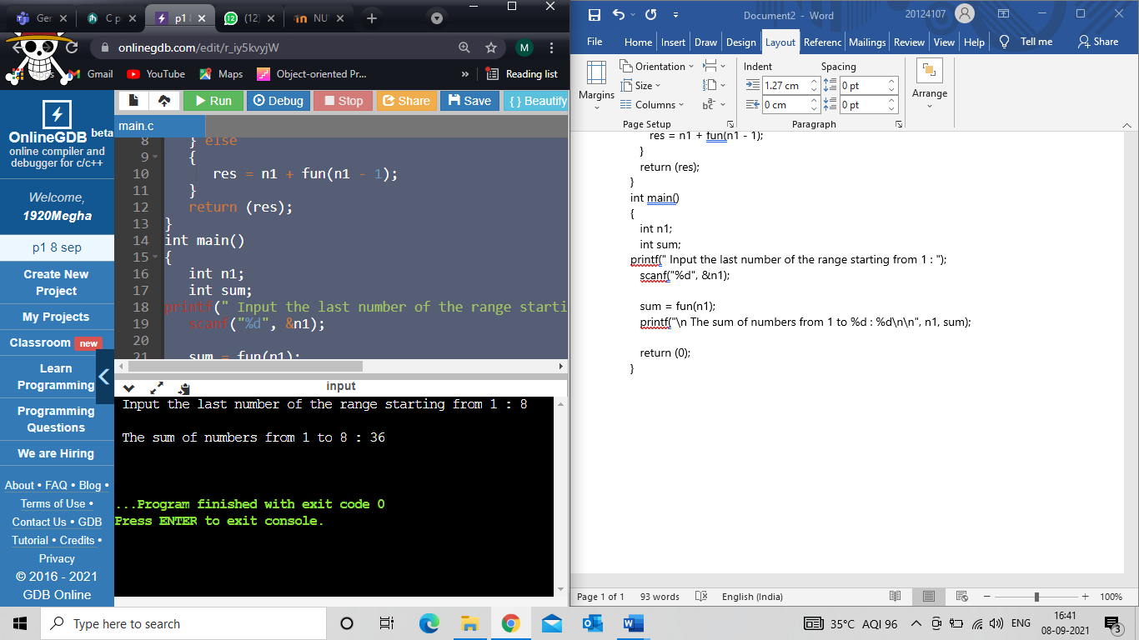

2) Write a program in C to count the digits of a given number using recursion.

#include<stdio.h>

int num(int n1)

{

static int ctr=0;

if(n1!=0)

{

ctr++;

num(n1/10);

}

return ctr;

}

int main()

{

int n1,ctr;

printf(" Input a number : ");

scanf("%d",&n1);

ctr = num(n1);

printf(" %d has %d digits",n1,ctr);

return 0;

}

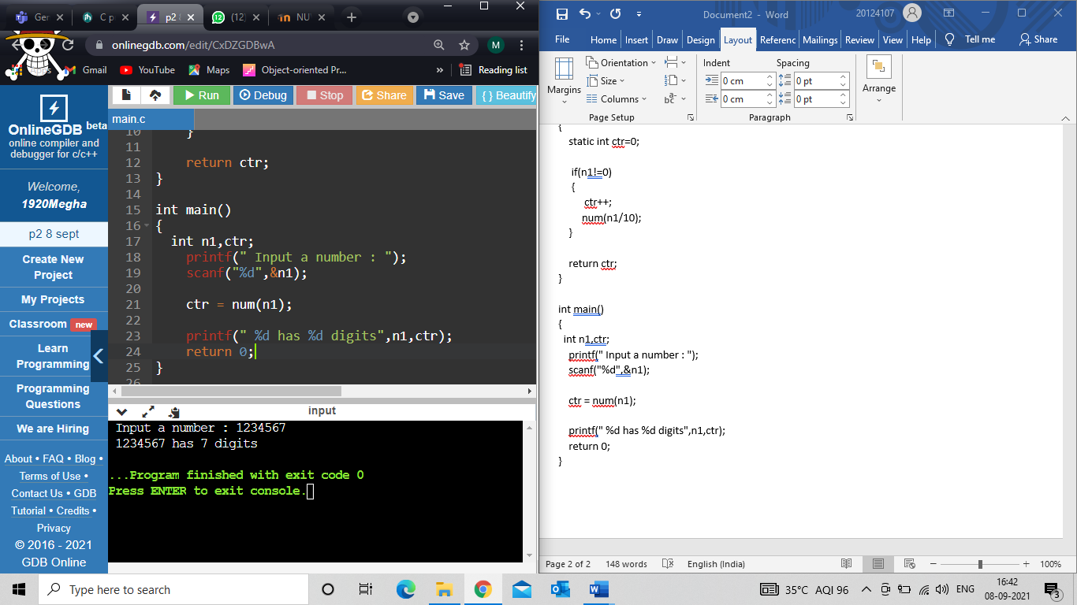

3) Write a program in C to print Fibonacci Series using recursion.

#include<stdio.h>

void series(int n){

static int n1=0,n2=1,n3;

if(n>0){

n3 = n1 + n2;

n1 = n2;

n2 = n3;

printf("%d ",n3);

series(n-1);

}

}

int main()

{

int n1=0,n2=1,n3,i,n;

printf("Enter the number of elements for printing fibonacci series:");

scanf("%d",&n);

printf("\n%d %d ",n1,n2);

series(n-2);

return 0;

}

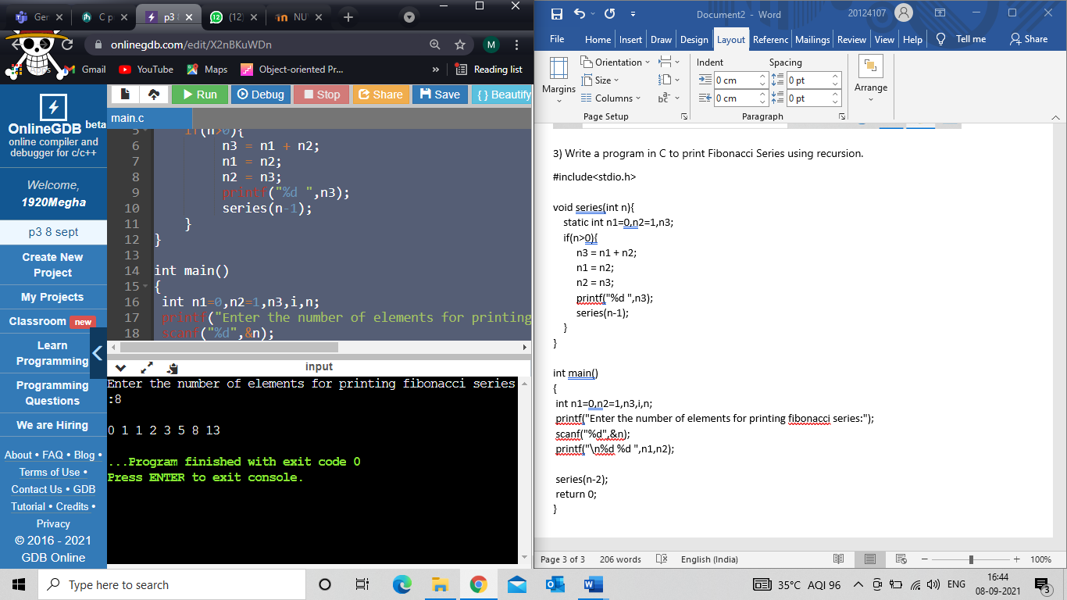

4) Write a program in C find GCD of two numbers using recursion.

#include <stdio.h>

int hcf(int n1, int n2) {

if (n2 != 0)

return hcf(n2, n1 % n2);

else

return n1;

}

int main() {

int n1, n2,ans;

printf("Enter two numbers to find their GCD: ");

scanf("%d %d", &n1, &n2);

ans=hcf(n1, n2);

printf("G.C.D of %d and %d is %d.", n1, n2,ans);

return 0;

}

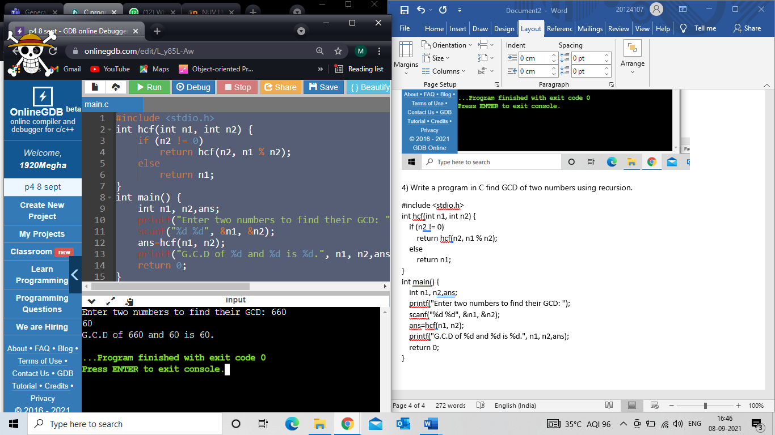

5) Write a program in C to reverse a string using recursion.

# include <stdio.h>

void reverse(char *str)

{

if (*str)

{

reverse(str+1);

printf("%c", *str);

}

}

int main()

{

char a[30];

printf("enter a string to reverse\n");

scanf("%s",a);

printf("revere=\t");

reverse(a);

return 0;

}

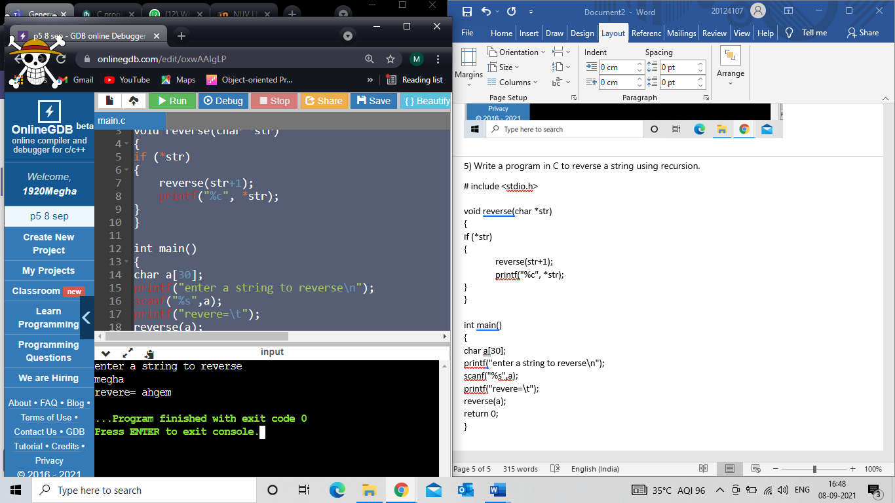

6) Write a program in C to check whether a given string is Palindrome or not using recursion.

#include <stdio.h>

#include <string.h>

void checkif(char word[], int index)

{

int len = strlen(word) - (index + 1);

if (word[index] == word[len])

{

if (index + 1 == len || index == len)

{

printf("is a palindrome\n");

return;

}

checkif(word, index + 1);

}

else

{

printf("is not a palindrome\n");

}

}

int main()

{

char a[30];

printf("Enter a word to check if it is a palindrome\n");

scanf("%s",a);

checkif(a, 0);

return 0;

}

